**Testing Coverage**

As part of requirements for all sprints, unit tests were implemented for all services and controllers in the backend. Running a small script “pnpm run test:cov” allows us to run the tests with coverage.

Below is a screenshot of the coverage, as generated by the package, with 85.34% coverage.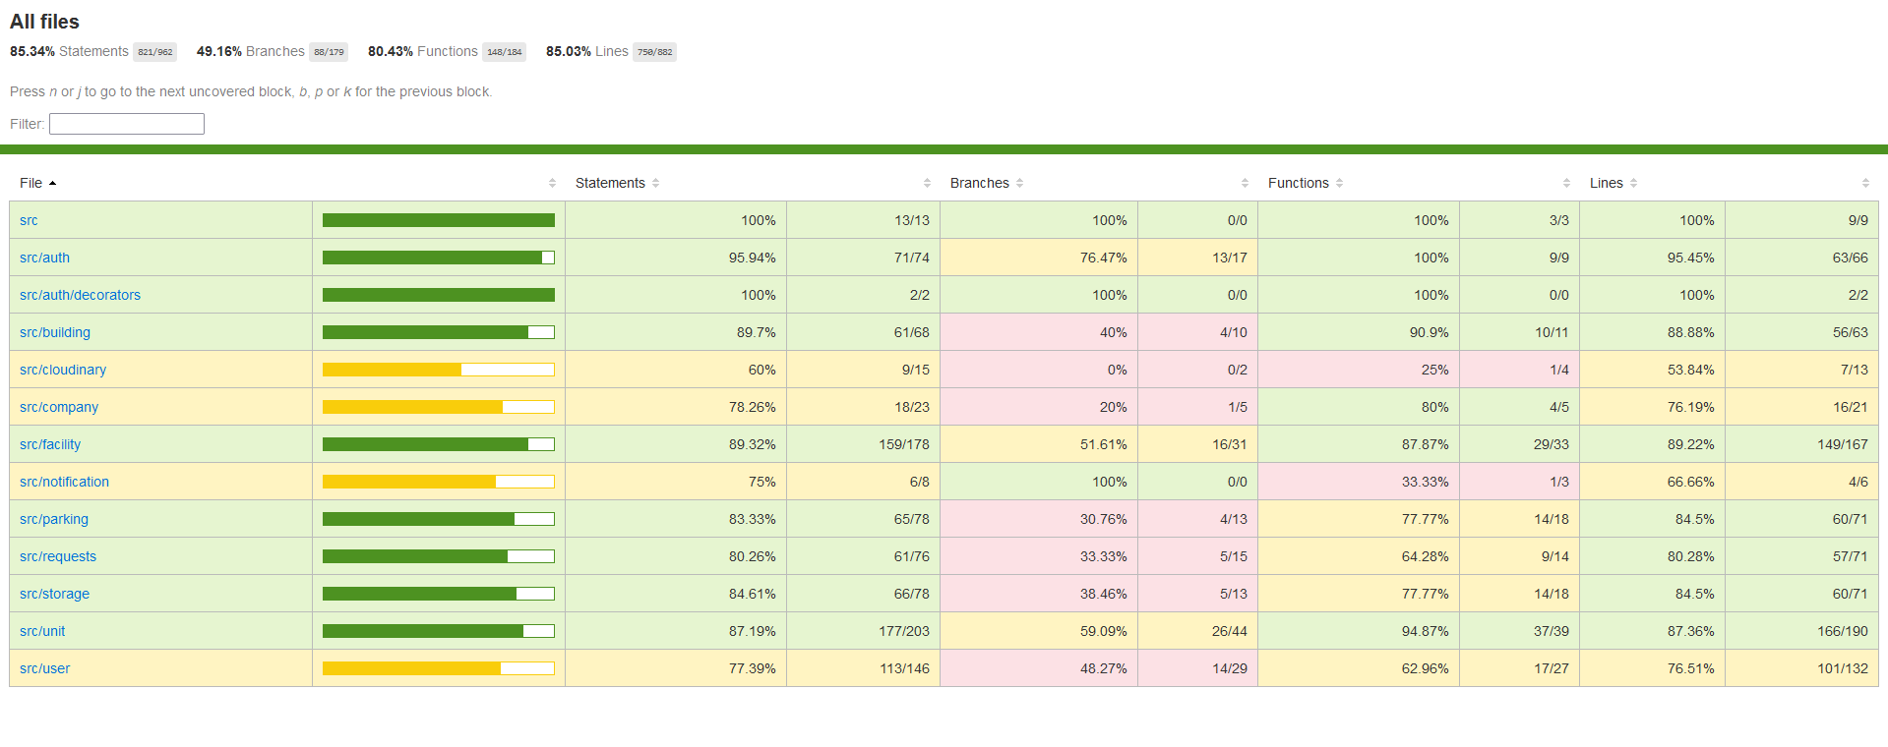

As part of the requirements for sprint 4, integration tests were introduced. Running the small script “pnpm run test:e2e” displays the testing results. Below is a screenshot of the first integration test that “creates a manager”. Integration tests will be continued to ensure stability of the app.

